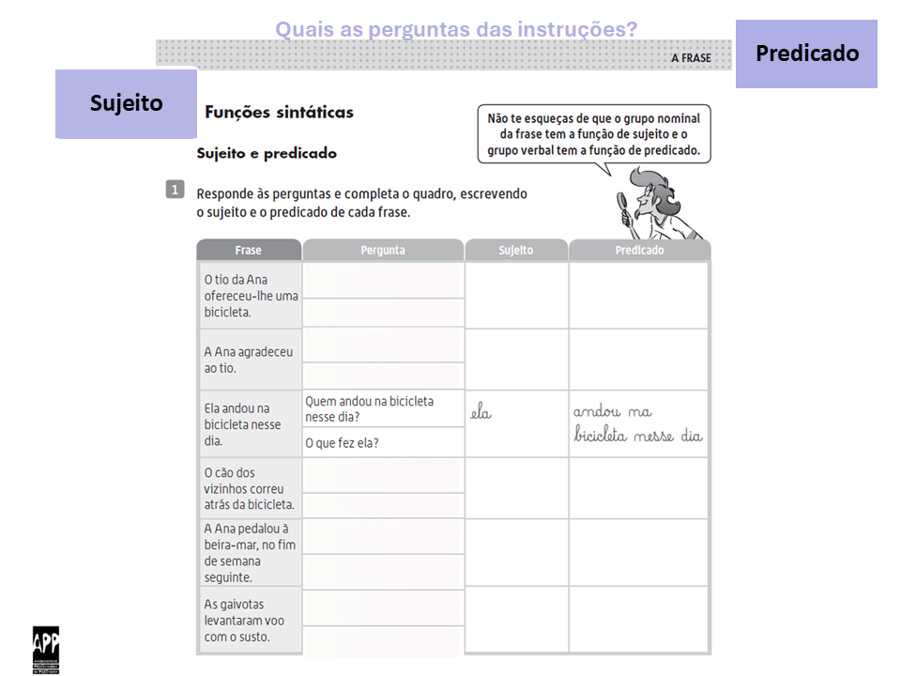
1
2
1
2
1
2
1
2
1
2

